**1. Program to display your using name using characters.**



**2. Program to add, subtract, multiply, and divide two whole numbers.**

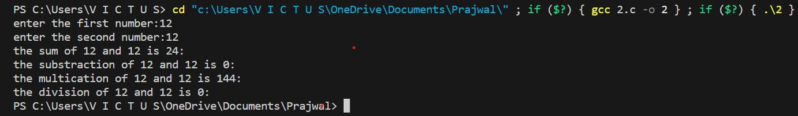

**3. Program to find simple interest.**

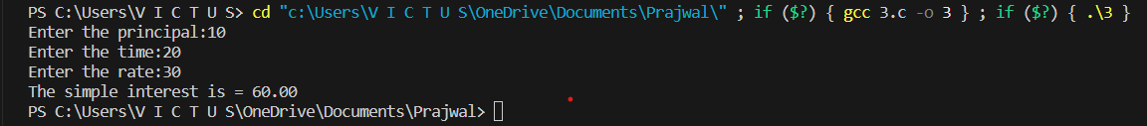

**4. Program to convert a temperature given in Celsius to Fahrenheit.**



**5. Program to find square root of a given number.**



**6. Program to find power of a given number. Hint: pow(a, b), a and b are user inputs.**



**7. Program to find area and circumference of circle.**



**8. Program to find area and perimeter of a rectangle.**



**9. Program to find price of n mangos given the price of a dozen mangos.**



**10. Program to convert pounds to kilograms.**



**11. Program to find the rupee equivalent of U.S. dollars.**



**12. Program to print a six digit integer in reverse order.**



**13. Program to sum the digits of a positive integer which is 5 digits long.**



**14. Program to express a length given in millimeters in meters, centimeters, and millimeters.**



**15. Program to calculate discount. If purchased amount is greater than or equal to 1000,**

**discount is 5%.**



**16. Program to calculate discount. If purchased amount is greater than or equal to 1000,**

**discount is 5%. If purchased amount is less than 1000, discount is 3%.**



**17. Program to calculate discount**

**a) If purchased amount is greater than or equal to 5000, discount is 10%**

**b) If purchased amount is greater than or equal to 4000 and less than 5000, discount is 7%**

**c) If purchased amount is greater than or equal to 3000 and less than 4000, discount is 5%**

**d) If purchased amount is greater than or equal to 2000 and less than 3000, discount is 3%**

**e) If purchased amount is less than 2000, discount is 2%**



**18. Program to check whether a number is even or odd.**



**19. Program to calculate the simple interest.**

**a) If balance is greater than 99999, interest is 7 %.**

**b) If balance is greater than or equal to 50000 and less than 100000interest is 5 %.**

**c) If balance is less than 50000, interest is 3%.**

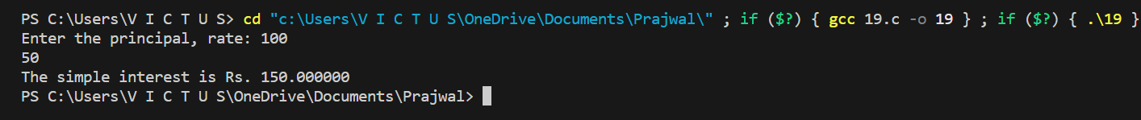

**20. Admission to a professional course is subject to the following conditions:**

**a) Marks in mathematics >= 60**

**b) Marks in physics >= 50**

**c) Marks in chemistry >= 40**

**d) Total in all three subjects >= 200**

**OR**

**Total in mathematics and physics >=150**

**Write a program to process the applications to list eligible candidate.**

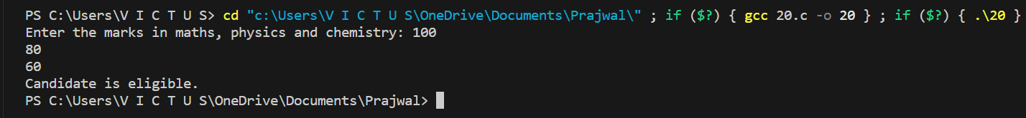

**21. A leap year should meet the following condition:**

**a) For non-century years it should be exactly divisible by 4.**

**b) For century years it should be exactly divisible 400.**

**Write a program to check a year for leap.**



**22. Rates of tax on gross salary are as shown below:**

**23. Income Tax**

**Less than 10,000 Nill**

**Rs. 10,000 to 19,999 10%**

**Rs. 20,000 to 39,999 15%**

**Rs. 40,000 to above 20%**

**Write a program to compute the net salary after deducting the tax for the given information.**



**24. Jet Company gives 5% commission to its salesman if their monthly sales are less than Rs.**

**10,000 and a 10% commission if it is equal to or greater than Rs. 10,000. Write a program to**

**calculate commission at the end of the month.**



**25. A bank accepts deposits for one year or more and the policy it adopts on interest rate is as**

**follows:**

**a) If a deposit is less than Rs. 1,000 and for 2 or more years the interest rate is 5 percent**

**compounded annually.**

**b) If a deposit is Rs. 1,000 or more but less than Rs. 5,000 and for 2 or more years the**

**interest rate is 7 percent compounded annually.**

**c) If a deposit is more than Rs. 5,000 and is for 1 year or more the interest rate is 8 percent**

**compounded annually.**

**d) On all deposits for 5 years or more interest is 10 percent compounded annually**

**e) On all other deposits not covered by the above conditions the interest is 3 percent**

**compounded annually.**

**At the time of withdrawal a customer data is given with the amount deposited and the**

**number of years the money has been with the bank. Write a program to obtain the money in**

**the customer’s account and the interest credited at the time on withdrawal.**

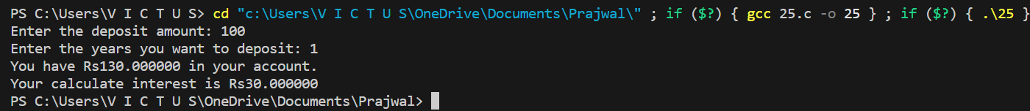

**26. Program to print the largest number among three numbers input by the user.**

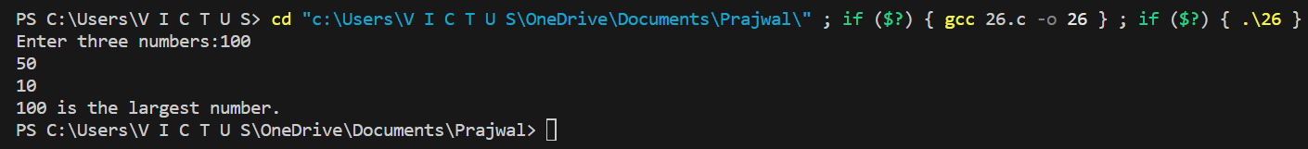

**27. Program to find the roots of a quadratic equation using discriminant.**

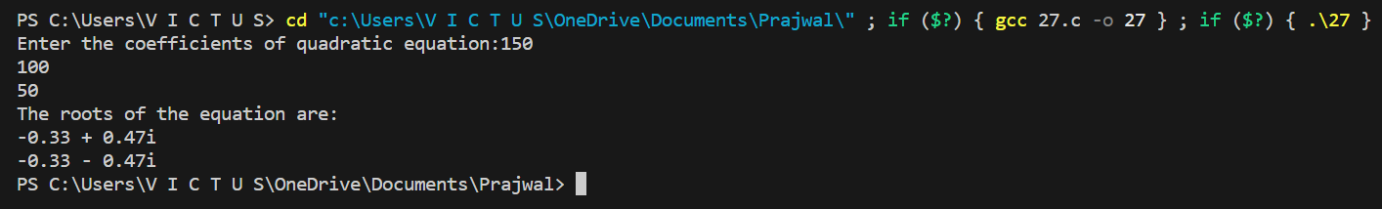

**28. Program to compare two numbers.**



**29. Given marks in five subjects. Write a program (a) to display “PASS” or “FAIL” if assumed**

**pass marks is 45 in each subject, (b) to find percentage of marks obtained, and (c) to find**

**division for “PASS” students assuming that 80% and above for “DISTINCTION”, 60% and**

**above for “FIRST DIVISION” otherwise “SECOND DIVISION”.**

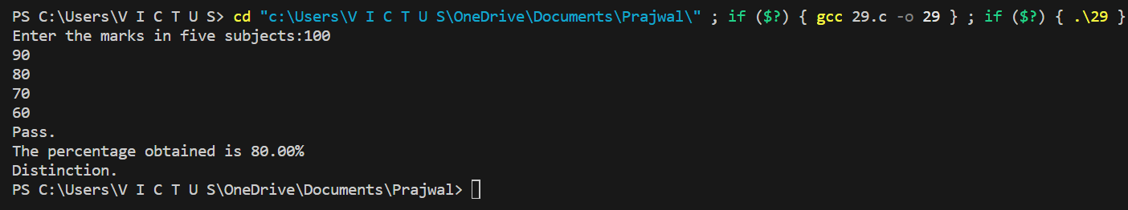

**30. Write a program using switch statement to display EXCELLENT, VERY GOOD, GOOD,**

**SATISFACTORY, or FAIL if the user enters A, B, C, D, or E respectively.**



**31. Program to display number of days in a month using switch statement.**



**32. Write a program using switch statement to develop a simple calculator for +, -, *, /, and %**



**33. A cloth showroom has announced the following seasonal discounts on purchase of items**

**-----------------------------------------------------------------------------------------------------**

**Purchase amount Discount**

**-----------------------------------------------------------------------------------------------------**

**Mill cloth Handloom items**

**-----------------------------------------------------------------------------------------------------**

**0 – 100 - 5%**

**101 – 200 5% 7.5%**

**201 – 300 7.5% 10%**

**Above 300 10% 15%**

**-----------------------------------------------------------------------------------------------------**

**Write a program using switch and if statements to compute the net amount to be paid by a**

**customer.**

**34. Program to display your name 10 times using all the three looping statements.**

**35. Program to display first n natural numbers, their sum, and their average using all the three**

**looping statements.**

**36. Program that displays the temperatures from 0 degrees Celsius to 100 degrees Celsius and**

**their Fahrenheit equivalent.**

**37. Program to calculate sum of first 10 even number.**



**38. Program to find out sum of all numbers completely divisible by 5 among n numbers given**

**by the user.**

**39. Program to determine the sum of the harmonic series (1+ 1/2 + 1/3 + 1/4 + ... + 1/n) for a**

**given value of n.**



**40. Program to find the sum of the series 1 + x2+ 3x2+ 4x2+.....+nx2.**

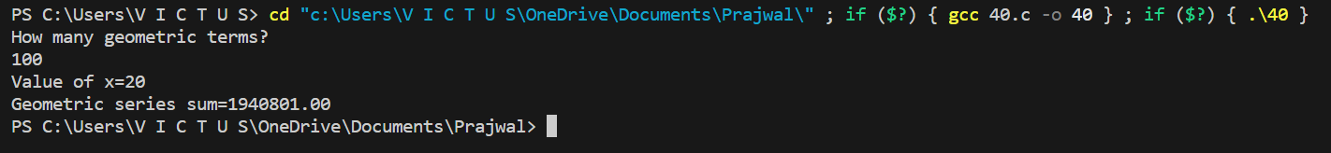

**41. Program that calculates the sequence 1/1! + 2/2! + 3/3! +.....+ n/n, Where n is the number of**

**input by the user.**



**42. Program to display sum of the following series up to n terms. Sum = x - x2+ x3- x4+.......**



**43. Program to find X of the following series for the given value of a and N.X = a – a2/2 +**

**a3/3 – a4/4..................up to N.**

**44. Given an integer, write a program to reverse and print it.**



**45. Program that computes the sum of the digits of the given integer number.**



**46. Given an integer, write a program to check it for palindrome.**



**47. Program to find factorial of a number.**



**48. Program to obtain the first 25 numbers of Fibonacci series.**



**49. Program to display all prime numbers less than 100.**



**50. Program to display all the leap years starting from 1900 to 2000.**

**51. Write a program to display the following menu**

**a. To find area of circle**

**b. To check the given number is odd or even.**

**c. To find the sum of N numbers.**

**d. Exit.**

**Perform above task until the user wants to exit.**

**52. Program to print the following outputs using for loops**

**1**

**2 2**

**3 3 3**

**4 4 4 4**

**5 5 5 5 5**

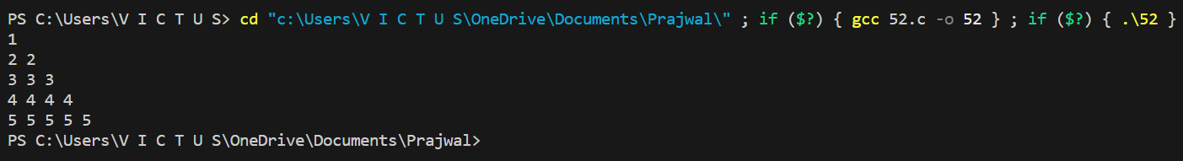

**53. Program to find greater number between two numbers using function.**

**54. Program using function to calculate and return sum of following series up to n terms; where**

**x and n are supposed as passed by main program; sum = x-x2+x3-x4+.....**

**55. A five digit positive integer is entered through the keyboard; write program using function to**

**calculate the sum of the digits of the number. The function should receive the integer from**

**main () and output also be printed through main ().**